**Project Requirement and Specification**

**on**

**Face Recognition Attendance System**

**(CSE V Semester Mini project)**

**2021-2022**



**Name: Harshit Saini**

**Class Roll No: 22**

**Section: K**

**DEPARTMENT OF COMPUTER SCIENCE AND ENGINEERING**

**GRAPHIC ERA HILL UNIVERSITY, DEHRADUN**

**ACKNOWLEDGMENT**

I would like to express our gratitude to The Almighty, the most beneficent and the most merciful, for completion of the project. I wish to thank my parents for their continuing support and encouragement. I also wish to thank them for providing me with the opportunity to reach this far in our studies.

I would like to appreciate my Project Guide Mrs Akshara Pande for her patience, support and encouragement throughout the completion of this project and for having faith in me.

**Harshit Saini**

**CSE-K-V-Sem**

**Session: 2021-2022**

**GEHU, Dehradun**

**ABSTRACT**

For every organization, today attendance is the most important thing to record the presence of someone. The presence of someone in an organization is a sign that the person is carrying out their obligations to come to the agency or organization.

Usually, attendance is done manually. It can be signed or called one by one. In this digital age, there AQ1 must be a change from this absence to be able to accelerate and provide time efficiency. We can use face recognition to record attendance from everyone present in an organization.

In this face recognition, many algorithms are performed to dissect and capture images of someone’s face, such as Machine Learning and Deep Learning. With this algorithm, the system can recognize a person’s face and record attendance from that person so that attendance activities are more efficient and faster.

**PROJECT INTRODUCTION AND MOTIVATION**

**About Project**

Face Recognition is a technology capable of identifying or verifying a person’s face with digital masking from image or video. So many methods in face recognition systems. Face recognition uses biometrics to map facial features from an image or video.

Face recognition can help verify the personal identity from the face of a person. With these features of face recognition, we think face recognition can help people to verify attendance. In today’s digital age, face recognition is very helpful in this era. Especially for work areas that require attendance verification. Maybe some parts are now relying on technology to verify attendance. But some still use traditional methods that take a long time.

Therefore face recognition is very helpful in terms of verifying attendance to speed up the process of recording and verifying the person. Face recognition is one of the most intensively studied technologies in computer vision, with new approaches and encouraging results reported every year. Face recognition approaches are generally classified as feature-based and holistic approaches. In holistic based approaches, recognition is done based on global features from faces, whereas in feature-based approaches, faces are recognized using local features from faces

The architecture of the projects includes basically these components:

1. Front-End (UI) [ Technologies Utilized: Tkinter, Python ].
2. Database [ Database Utilized: Mysql ]
3. OpenCV
4. Object/Face Detection Algorithm Used (Inbuilt Classifier) [ Haar Cascades Algorithm ]
5. Object/Face Recognition Algorithm Used (For Training DataSet) [ LBPH Algorithm ]

**METHODOLOGY**

Before the attendance management system can work, there is a set of data needed to be input into the system which essentially consist of the individual‟s basic information which is their ID and their faces.

The first procedure of portrait acquisition can be done by using the Camera to capture the faces of the individual. In this process the system will first detect the presence of a face in the captured image, if there is no face detected, the system will prompt the user to capture their face again until it meets a certain number of portraits which will be 10 required portraits in this project for each student.

The decision of storing only 10 portraits per student is due to the consideration of the limited storage space in the raspberry pi because the total number of students in the university is considered heavy.

Then, the images will undergo several pre-processing procedures to obtain a grayscale image and cropped faces of equal sized images because those are the prerequisites of using the EigenFaces Recognizer.

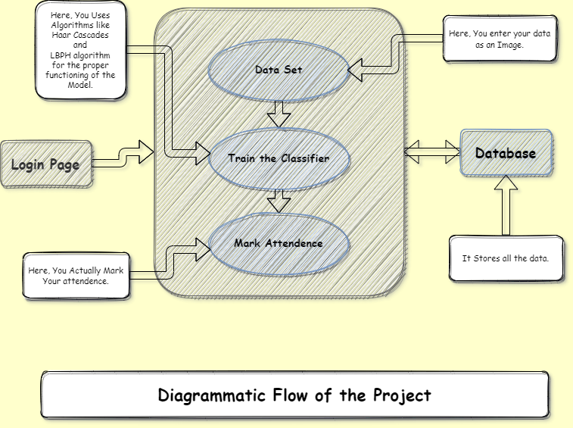

**SCREENSHOTS**

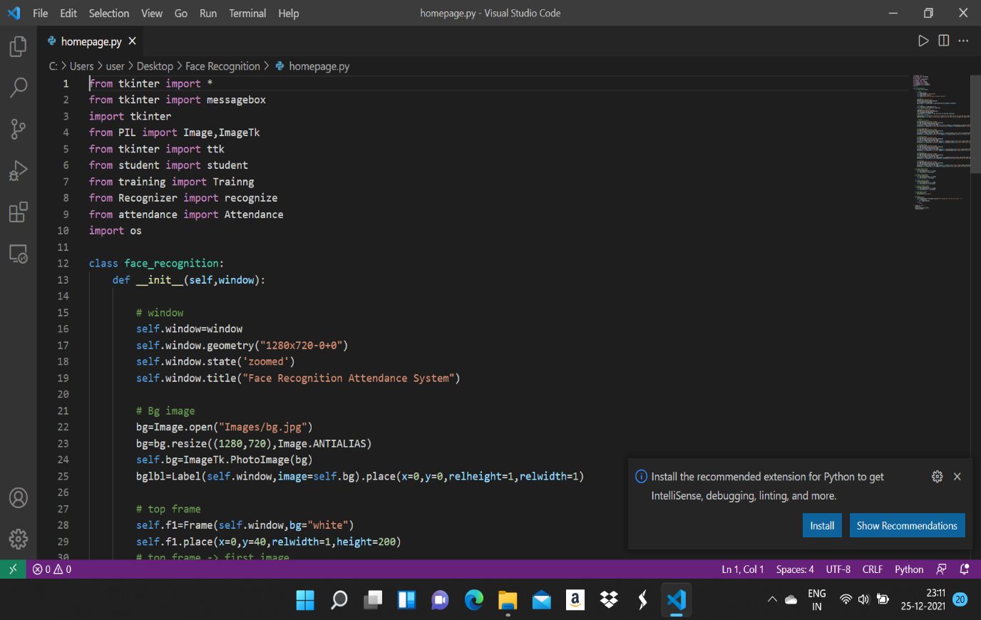

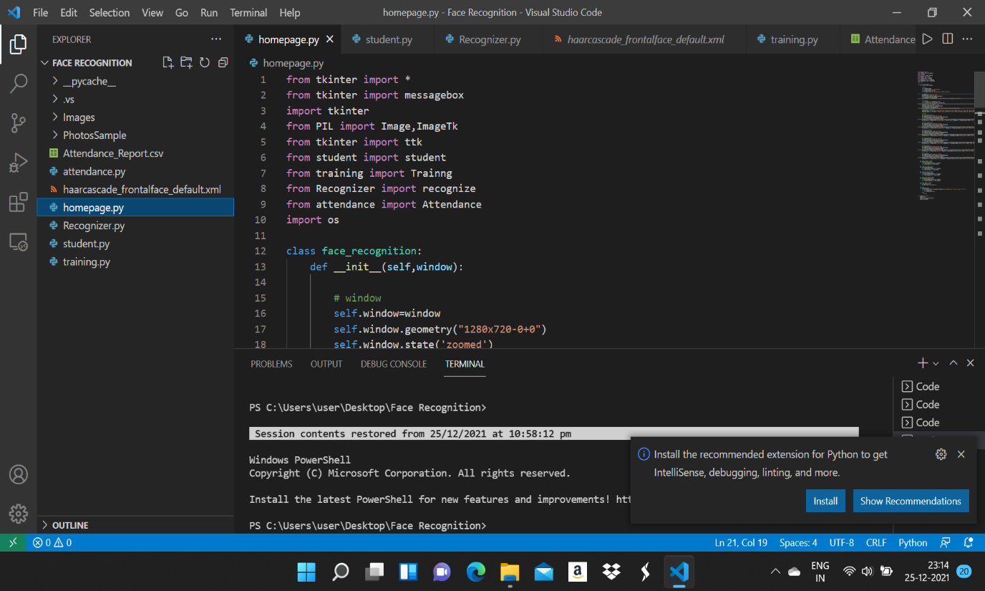

**REFERENCES**

1. **Python Official Site:** [**https://www.python.org**](https://www.python.org)
2. **Haar Cascade Documentation:** [**https://docs.opencv.org/3.4/db/d28/tutorial_cascade_classifier.html**](https://docs.opencv.org/3.4/db/d28/tutorial_cascade_classifier.html)
3. 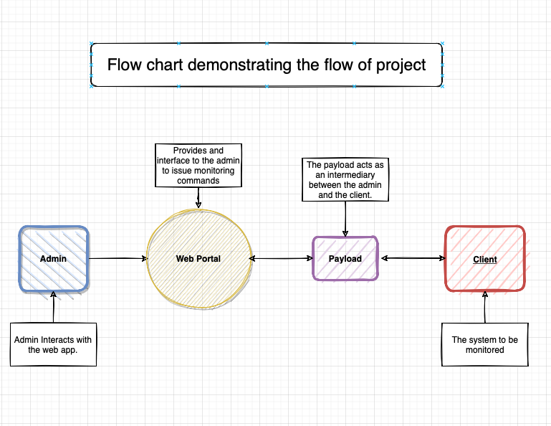**LBPH Algorithm:** [**https://iq.opengenus.org/lbph-algorithm-for-face-recognition/**](https://iq.opengenus.org/lbph-algorithm-for-face-recognition/)
4. **GeeksforGeeks**